**MANUSCRIPT DRAFT**

**COMPARISON OF STRUCTURAL AND METABOLIC BIOMARKERS OF NEURODEGENERATION FOR BRAIN AGE PREDICTION USING MACHINE LEARNING**

E. Doering1,2, G. Antonopoulos3,5, M. Hönig1,4, T. van Eimeren1,2, S. B. Eickhoff3,5, K. R. Patil5,5, A. Drzezga1,2,4 for the Alzheimer’s Disease Neuroimaging Initiative[1]

1University Hospital Cologne, Clinic and Policlinic for Nuclear Medicine, Cologne, Germany, 2German Center for Neurodegenerative Diseases, Positron Emission Tomography, Bonn, Germany, 3Research Center Juelich, Brain and Behavior (INM-7), Juelich, Germany, 4 Research Center Juelich, Molecular Organization of the Brain (INM-2), Juelich, Germany, 5Heinrich-Heine-University, Institute of Systems Neuroscience, Duesseldorf, Germany

Keywords: biological age, machine learning, Alzheimer’s disease

Objectives: Brain aging is characterized by anatomical and molecular changes. Deviations from the normal aging trajectory in the form of advanced brain aging relative to chronological age (“brain age gap”, *BAG*) is associated with cognitive decline. Such normal aging trajectories are typically estimated from magnetic resonance imaging (MRI), however, changes in neuronal glucose metabolism, visible on 18F-Fluorodeoxyglucose positron emission tomography (FDG-PET), likely precede anatomical changes observed on MRI. Here, we compare the accuracy of brain age estimation from FDG-PET and MRI, and we associate BAG derived from both modalities with cognitive impairment, and Alzheimer’s disease biomarkers. Furthermore, we present thresholds for the prediction of cognitive decline from BAG. Analyses were conducted in individuals without (CN) and with mild cognitive impairment (MCI).

Methods: Machine learning algorithms were trained to estimate brain age from 367 matched MRI or FDG-PET scans of CN from the Alzheimer’s Disease Neuroimaging Initiative using a nested cross-validation approach. BAG was computed and correlated with measures of amyloid and tau pathology in CN and MCI (n=513). Finally, BAG was used to predict a change in individuals' cognitive diagnosis after two years using cross-validated logistic regression. Thresholds for cognitive decline were estimated from the logistic regression output.

Results: FDG-PET (MAE=1.99 years) and MRI (MAE=1.89 years) predicted chronological age comparably. FDG-PET-derived BAG was more strongly associated with measures of amyloid in CN, whereas MRI-derived BAG correlated better with measures of cerebral amyloid and tau in MCI. In CN, FDG-PET-derived BAG significantly predicted cognitive decline, while both FDG-PET- and MRI-derived BAG were associated with an AD diagnosis after two years in MCI, however associations were stronger in MRI.

Conclusion:

Brain age is reliably estimated from FDG-PET or MRI. Amyloid-neuropathology, predisposing for Alzheimer’s disease, is related to features of advanced BAG in FDG-PET ahead of clinical onset of disease, and 18F-FDG-PET-derived BAG reliably predicts cognitive decline in CN. Onset of tau-related neurodegeneration and of pending conversion to AD is more strongly associated with increasing BAG on MRI.

**Graphical Abstract**

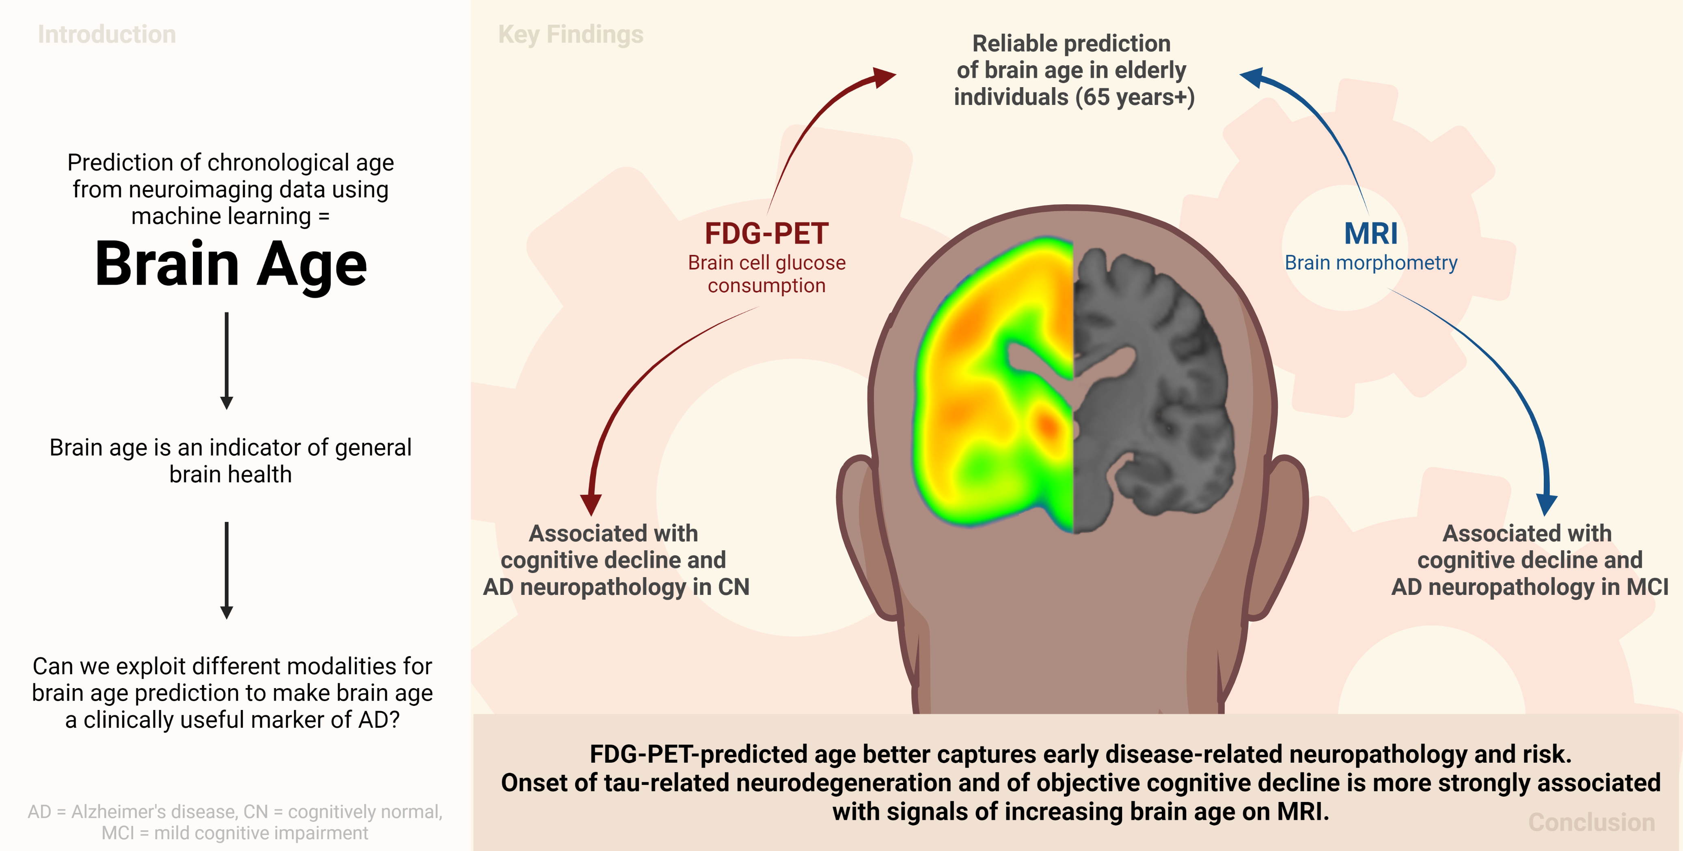

**1 Introduction**

Biological aging entails the change in or decline of various physiological functions. Human biological aging, as opposed to chronological aging, differs depending on the tissue under investigation – and advanced biological age of specific organs is associated with diseases of the same1. Biological age of the brain, i.e., *brain age*, is modeled via machine learning algorithms by predicting a person’s chronological age from their neuroimaging data. A positive deviation of brain age from chronological age indicates an advanced brain age (*brain age gap, “BAG”*) and it is associated with presence, or future development of cognitive impairment due to neurodegeneration2–6.

Age-related changes of the brain are most apparent from anatomical changes, such as loss of brain volume (atrophy), and molecular changes, such as a decline of neuronal metabolism (neuronal dysfunction). These two processes can be visualized by T1-weighted magnetic resonance imaging (MRI) and 18F-Fluorodeoxyglucose-PET (FDG-PET), respectively. As atrophy is preceded by neuronal dysfunction, FDG-PET is a slightly earlier indicator of neurodegeneration compared to MRI7,8. Yet, estimation of brain age is typically achieved using MRI, rather than FDG-PET. Only one recent study compared FDG-PET to the standard of MRI for brain age prediction, and the study showed slightly better performance of brain age prediction when using FDG-PET4. However, pre-processing of FDG-PET data was done using partial volume correction, thus, under consideration of information from MRI and the question arose whether this reflected combined information from both modalities, rather than unimodal FDG-PET superiority. Additionally, authors of the study showed that, in a heterogeneous sample of cognitively impaired individuals, both FDG-PET- and MRI-derived BAG are associated with cognitive performance, future cognitive decline (also in cognitively unimpaired individuals), and Alzheimer’s disease biomarkers, such as amyloid and tau pathology. Finally, regions important for the prediction of brain age differed between FDG-PET and MRI. Together, these findings argue for further exploration of FDG-PET-derived BAG, and its possibly superior performance in delineating earliest deviations from normal aging when cognitive impairment is not yet apparent. Furthermore, no threshold of BAG for elevated risk of cognitive decline has yet been published. Such a threshold might differ depending on the presence of known risk factors for cognitive decline. Eventually, a (potentially risk-factor dependent) threshold of BAG could aid clinicians in providing personalized prognoses of disease progression.

Here, we aimed to further investigate the unimodal potential of FDG-PET and MRI to serve as predictors of chronological age, using a cohort of cognitively normal individuals (CN), and patients with mild cognitive impairment (MCI). First, we compared the accuracy of BPA using FDG-PET or MRI in CN, with chronological age serving as ground truth. Then, we compared associations of FDG-PET- and MRI-derived BAG and cognitive performance/Alzheimer’s disease pathology in CN and MCI. Finally, we applied machine learning classification to predict cognitive decline (CD) from BAG and known risk factors in CN and MCI, and subsequently calculated a threshold for BAG for elevated risk of cognitive decline.

**2 Method**

**2.1 Participants**

Baseline T1-weighted MRI and FDG-PET scans of 367 CN and 513 individuals with MCI used in the preparation of this article were obtained from the Alzheimer's Disease Neuroimaging Initiative (ADNI) database ([adni.loni.usc.edu](https://ida.loni.usc.edu/collaboration/access/adni.loni.usc.edu)). The primary goal of ADNI has been to test whether biological markers and clinical and neuropsychological assessment can be combined to measure the progression of MCI and dementia. To be included, time passed between the FDG-PET and MRI scan of the same individual could not exceed one year, and individuals had to be at least 65 years of age. The age restriction was due to the fact that age at onset of AD is around 65 years, and CN data below this age is rare in ADNI, thus potentially creating algorithms not suited for age prediction below 65 years. CN and MCI diagnoses were based on the ADNI standard: A diagnosis of CN entailed individuals had no significant impairment in memory or cognitive functions or activities of daily living. An MCI diagnosis was provided to individuals with measurable impairment in cognitive function in the absence of dementia or significant impairments of daily living (https://adni.loni.usc.edu/methods/documents/).

To test our algorithms in an external dataset, we additionally considered 59 CN elderly  participants from the Open Access of Imaging Studies-3 (OASIS-3) database (https://www.oasis-brains.org/)20. Given the small sample size of participants who received both an MRI and FDG-PET scan within 12 months, we eliminated this time constraint for the OASIS test set, while still only individuals above 65 years at acquisition of the earlier scan were considered.

**2.2 Acquisition & Preprocessing of Biomarkers of Neurodegeneration**

FDG-PET scans in both samples were acquired dynamically 30-60 minutes (6x5min frames) after injection with an average dose of 185 MBq (5mCi) and downloaded with minimal pre-processing (“Co-registered, averaged”-format). Pre-processing was performed using the Statistical Parametric Mapping 12 toolbox (SPM12; [www.fil.ion.ucl.ac.uk](http://www.fil.ion.ucl.ac.uk)): All 18F-FDG-PET scans were aligned to the anterior commissure/posterior commissure, and subsequently co-registered and normalized to a template in standard space. Lastly, standardized uptake value ratios (SUVr) were calculated (reference: pons21).

T1-weighted MRI scans were acquired on XX-T scanners according to the ADNI MRI acquisition protocol22. First, scans were pre-processed using denoising (spatial-adaptive Non-Local Means), spatial registration, bias-correction, and skull-striping. Then the images are segmented by an adaptive maximum a posteriori approach (Rajapakse et al. 1997) with partial volume model (Tohka et al. 2004). For non-linear transformation, the Geodesic Shooting Algorithm (Ashburner & Friston 2011) was used based on SPM12.

**2.3 Calculation of brain-predicted age**

Mean gray matter volume and SUVr were extracted for MRI and FDG-PET, respectively, using a composite atlas containing 200 cortical23 and 16 sub-cortical regions24. Estimation of brain age was achieved using the Julearn library (https://juaml.github.io/julearn/main/index.html), which is based on the scikit-learn library25 in Python 3.8.5. We applied a nested cross-validation approach, where ADNI data of CN individuals was split in a stratified manner into five different train (70%) and a test set (30%). Through stratification, the original proportions of young-old (65 - 74 years, ~51.7% of our sample), middle-old (75 - 84 years, ~40.6% of our sample) and oldest-old classes (85 years+, ~7.7% of our sample)26 in the whole ADNI dataset were maintained in the train and test sets. Each train set was then used to derive a final model for brain age prediction using a pipeline consisting of 1) outlier exclusion, 2) cross-validated prediction, and 3) bias correction (see Fig 5).

1. Outlier exclusion was performed to ensure data quality in an automated manner. Interquartile ranges (IQR) were inferred from the training sets, and subsequently applied to CN test sets, where subjects outside 6xIQR were removed from the analyses (*n*ADNI = 2, *n*OASIS = 7). Importantly, as previous works have shown, MCI subjects show an advanced brain age, which translates to a reduced signal in age-relevant brain regions6. Thus, outlier exclusion was not applied to the MCI sample.
2. To estimate BPA using FDG-PET or MRI, we compared relevance vector regression (RVR) and support vector regression (SVR). These machine learning models are prominently used for brain age prediction and are especially suited for training on small datasets27. Optimal (hyper)parameters were determined using five-fold stratified cross-validation in scikit-learn (for a list of hyperparameters, see Supplementary Materials Table 1). During each iteration of cross-validation, four parts of the training data were first scaled (by removing the median and scaling the data according to the IQR, “robust scaler” from the scikit-learn library) and then used to fit the models. The respective scaling parameters were subsequently applied to the validation set (fifth part of training data). Fitted models were used to predict CA from either neuroimaging modality in the validation set and these predictions were stored for bias-correction. As a result of cross-validation, one optimal RVR and one optimal SVR was yielded, where “optimal” refers to the respective (hyper-)parameter configuration that allowed for the smallest average MAE between CA and BPA across the validation sets, and the final model was the one with the smallest average MAE across the remaining two optimal models.
3. BPA is subject to a frequently reported bias, in which BPA of older individuals is under- and BPA of younger individuals is overestimated28, regardless of the data or method under consideration29. Several approaches have been suggested for the correction of this bias, which can be broadly summarized into methods including CA in the correction and methods not including CA in the correction30. Bias correction was inferred from validation folds, and estimated parameters were subsequently applied to the test folds. To obtain an in-depth understanding of the effect of the different methods of bias correction on the prediction of CA from MRI and FDG-PET in our data, we implemented both following previous approaches28,31 and compared them with regards to the number of test folds, where bias was successfully eliminated. Bias correction with CA enabled bias elimination on all test folds (see Supplementary Materials for a description of bias-correction without CA and Supplementary Table S4 for results of the methodological comparison) and was thus used for the calculation of BA. Thus, a linear regression model was fit on BAG versus CA. Bias-free brain age was calculated using slope (ɑ) and an intercept (β):

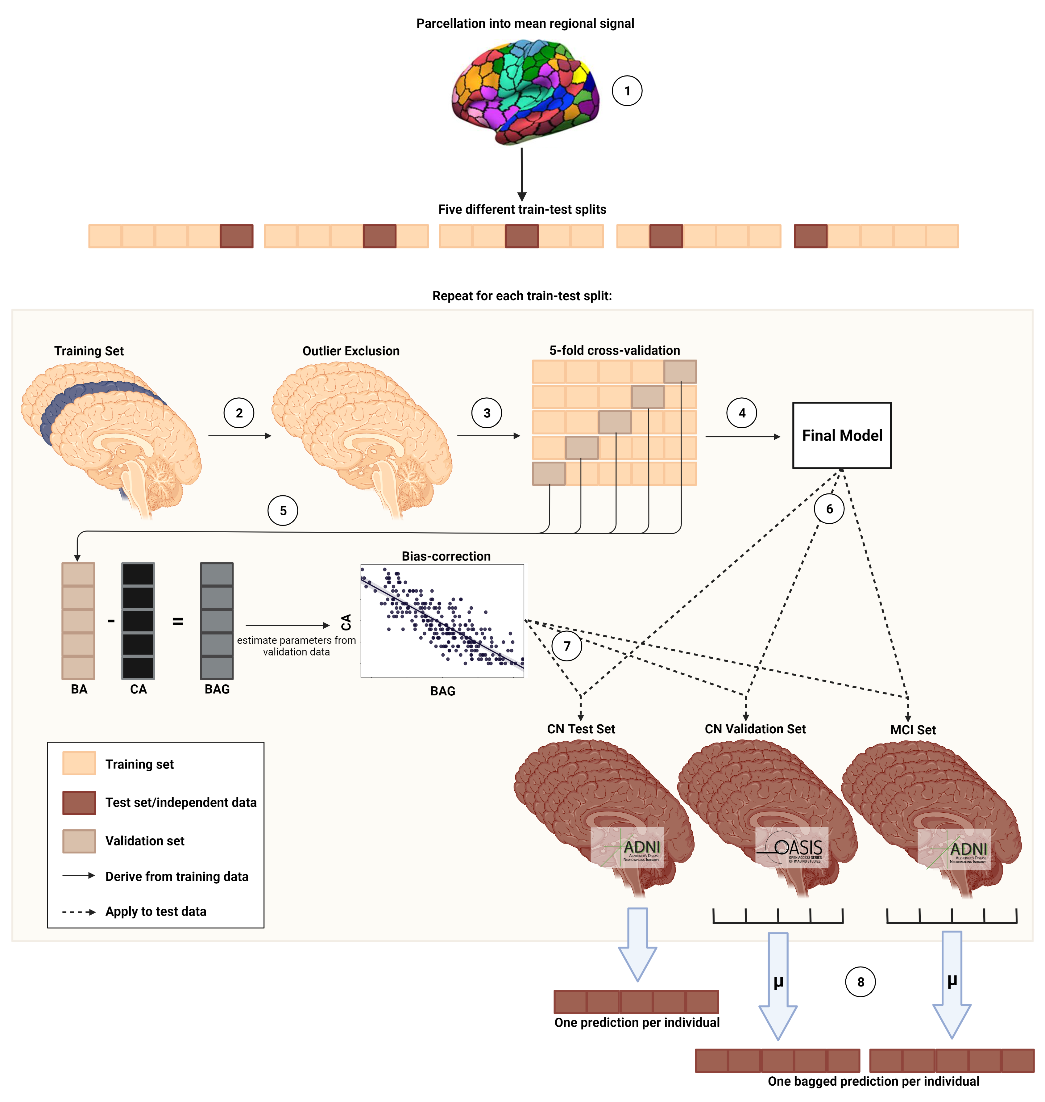

**Fig 1. Nested cross-validation approach for brain age prediction.** Five different train-test splits were used to train and test the models. (1) Mean regional gray matter volume or SUVr were inferred from a composite atlas. (2) Outlier exclusion ranges were inferred from the training data, and applied to both the training and test data. (3) Models were trained using five-fold cross-validation. (4) The model with the smallest MAE on the validation folds was chosen as the final model. (5) BA and CA from the validation folds was used to derive bias correction parameters. (6) The final model was subsequently applied to the test sets. (7) Bias correction parameters were applied to predictions in the test set. (8) Mean of predictions across five models is considered as final prediction for CN Validation and MCI set. BA = brain age; CA = chronological age; BAG = brain age gap

$${Predicted age}_{corrected with CA}={Predicted age}_{uncorrected}-(α*CA+β)$$

As a result of the above described nested cross-validation approach, we obtained five final models per modality, yielding one prediction per (non-outlier) subject in the CN sample (n = 345), and five predictions per (non-outlier) subject in the CN_validation (rangen = [52, 54]) and MCI sample (n = 513). For each individual, BAG was calculated as BPA – CA. MAE and average BAG of all samples was compared between modalities using a paired t-test.

**2.4 Associations of BAG with cognitive performance & AD neuropathology**

To assess the associations of BAG with cognitive performance, BAG was correlated with two composite scores, ADNI-MEM32 and ADNI-EF33. Age, sex, years of education and APOE-ε4 carriership status were entered as covariates in all correlations and significance levels were Bonferroni-corrected. ADNI-MEM combines several scores used to evaluate individuals’ memory performance from the Rey Auditory Verbal Learning Test, Alzheimer’s Disease Assessment Scale and Mini Mental State Exam. ADNI-EF is a summary score of several executive function tasks, including: Category Fluency, Trails, Digit span backwards, Wechsler Adult Intelligence Scale-R Digit Symbol Substitution, Number Cancellation, and Clock Drawing items.

To assess the associations of BAG with AD neuropathology, BAG was correlated with amyloid deposition in the brain (AV45-PET), as well as with amyloid, tau and phosphor-tau accumulation in cerebrospinal fluid (CSF). Age, sex, years of education and APOE -ε4 carriership status were entered as covariates in all correlations and significance levels were Bonferroni-corrected. For AV45-PET, mean standardized uptake value ratios (SUVr) are publicly available from previous analyses34–37. Briefly, the scans were co-registered to corresponding MRI images in native space and SUVrs were calculated voxel-wise using the whole cerebellum as a reference region. Global SUVr was then calculated using a brain mask including frontal, anterior/posterior cingulate, lateral parietal and lateral temporal regions, with amyloid positivity being defined with a cut-off of 1.1134. CSF measures of amyloid, tau and phospho-tau were acquired via lumbar puncture and analyzed using the Roche Elecsys® beta-Amyloid(1-42), Total Tau and Phospho Tau (181p) immunoassays38. The CSF cut-off for amyloid positivity was 1100 pg/ml39. The measuring range of the beta-amyloid assay is 200 – 1700 pg/ml. The number of tau PET scans already evaluated for SUVr in the current cohorts was too small to include this biomarker into the current analyses.

Finally, BAG residuals were created to test whether the observed associations are driven by a specific BAG category, using

Associations of BAG with cognitive performance and AD neuropathology were finally evaluate

**2.5 Prediction of cognitive decline**

Finally, cognitive decline was predicted from BAG of both modalities, amyloid status, APOE-ε4 carriership and years of education in samples balanced for cognitive decline, and matched for age and sex as depicted in **Fig 2**. Cognitive decline was defined as a change in cognitive diagnosis category within two years (inclusive) after BAG assessment. Thus, CN who received a diagnosis of MCI or dementia within two years were cognitive “decliners”, while CN who maintained the CN diagnosis until their year two follow-up examination yielded the group of “stables”. For MCI, decliners were those individuals who progressed to dementia within two years. A dementia diagnosis at follow-up entailed presence of dementia symptoms, abnormal memory and cognitive function and fulfillment of NINCDS/ADRDA criteria for probable AD. Due to unclear causality, MCI patients who were diagnosed as CN after two years were disregarded in the current analyses (n=19). As only a small fraction of individuals showed cognitive decline within two years, we repeated our analyses twice, with different sets of stable individuals. Cognitive decline in CN or MCI was predicted from FDG-PET BAG, MRI BAG, amyloid status (CSF), APOE-ε4 carriership status and education using a logistic regression classifier with 10-fold cross-validation. Amyloid status was not available for all individuals, therefore analyses were conducted in two ways: once including individuals with missing amyloid information (NA values coded as a separate category and amyloid negativity coded as reference; “whole samples”), and once excluding these individuals (“complete samples”). The predicted probability of cognitive decline for each individual was plotted, and the BAG closest to a probability of 50% yielded the threshold for elevated risk of cognitive decline.

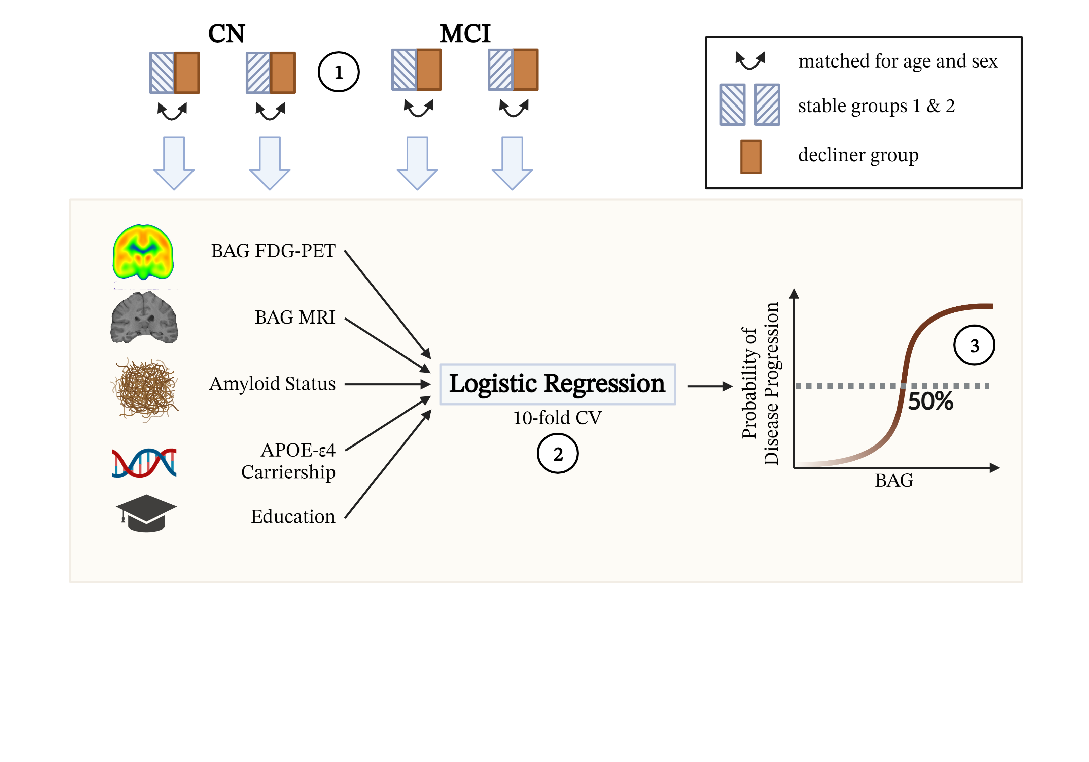

**Fig 2. Estimation of a BAG threshold for cognitive decline.** (1) Two different groups of stables were matched in age and sex to the decliner group. (2) 10-fold cross-validated prediction of cognitive decline within two years was conducted with FDG-PET and MRI BAG, as well as amyloid status, APOE-ε4 carriership and education as predictors. (3) The BAG threshold for increased risk of cognitive decline was inferred from 50% probability of cognitive decline in the cross-validated classification output.

To derive a cut-off of BAG for CD, we extracted significant predictors and built a new logistic regression classifier with them. In these models, the cut-off was then defined to correspond to 50% predicted probability of CD.

**3 Results**

**3.1 Participants**

This study included 879 FDG-PET and MRI scans (respectively) from the Alzheimer’s Disease Neuroimaging Initiative (ADNI) database (“CN” and “MCI” samples, adni.loni.usc.edu) and 59 from the Open Acces of Imaging Studies-3 database (OASIS-3). Scans from the ADNI database were selected such that FDG-PET and MRI scans from the same individual were not more than one year apart (CN: μ = 31 days, SD = 29 days[2], 338 of 379 FDG-PET scans acquired after day of MRI scan; MCI: μ = 29 days, SD = 26 days, 453/513 FDG-PET scans acquired after day of MRI scan). Data was split into three samples: the “main” ADNI sample of CN (“CN”, n = 367) was used to train models and yield predictions for later association of BAG with cognitive performance, neuropathology and cognitive decline in CN. The smaller sample of CN derived from the OASIS-3 (“CN_validation”, n = 59) was used to validate prediction accuracy (measured as the mean absolute error, MAE) as a hold-out dataset. Finally, predictions for the ADNI sample of 513 MCI patients (“MCI”) were used to associate BAG with cognitive performance, neuropathology and cognitive decline in MCI. To be included, individuals had to be 65 years or older. Chronological age was considered in whole years. OASIS participants were significantly younger than ADNI participants (p < .01), especially in the MRI cohort. Compared to CN, participants in the MCI sample had a significantly lower percentage of females (χ2 = 1.5, p < .01), lower MMSE (t(424)=5.38, p < .001) and a higher percentage of amyloid positivity (χ2 = 43.7, p < .001).

|  |  |  |  |  |
| --- | --- | --- | --- | --- |
| **Table 1.** Overview of samples | | | | |
|  | CN | CN_validation | MCI |
| *n* total | 367 | 59 | 513 |
| Age [avg. years (SD)] | 74.2 (5.68) (PET)  74.2 (5.67) (MRI) | 71.7 (4.15) (PET)/  70.4 (4.17) (MRI) | 74.9 (5.77) |
| Sex [%female] | 51 | 59 | 40 |
| CSFAβ1-42 Status  (-/+/NA) | 171/111/85 | NA | 121/270/122 |
| MMSE [avg. score] | 29 (1.24) | 29 (.85) | 28 (1.77) |
| Education [avg. years (SD)] | 16 (2.72) | 16 (2.70) | 16 (2.70) |

**3.2 Precision of brain-predicted age**

To compare the potential of FDG-PET and MRI to predict chronological age, we used a nested five-fold cross-validation approach, yielding one test prediction for (almost[3]) every subject in the ADNI CN sample, and five test predictions for each subject in the CN_validation and MCI sample. Two types of models previously recommended for small sample sizes9 were implemented for brain age prediction: support vector regression (SVR) and relevance vector regression (RVR). SVR models outperformed

RVR models in each fold of the outer-loop cross-validation in both modalities (Table 2). Atlas-derived mean regional signal from FDG-PET and MRI both predicted chronological age comparably well, i.e., with low mean absolute errors (MAE = |BPA – CA|). In the ADNI-derived CN test sets, individuals’ BPA as assessed with FDG-PET and MRI was on average very close to their actual age, as inferred from the low mean difference in days (*mean error, “ME*”) and in absolute days (*mean absolute error,* “*MAE”*), thus demonstrating high potential to capture brain aging in a CN cohort. The OASIS-derived CN_validation sample showed similar MAEs as the ADNI sample, although chronological age was slightly better predicted from FDG-PET as compared to MRI, as reflected in a lower MAE across the five models yielded from the outer cross-validation loop. A probable explanation for the higher MAE in the CN_validation MRI sample is that the age distribution in this sample deviated more from the age distribution in the ADNI train sets compared to CN_validation PET samples. In the MCI test sets, individuals’ brain-predicted age as assessed with FDG-PET and MRI was on average .77 and 1.57 years older than their chronological age, respectively, thus reflecting the expected advancement of brain age in this population. The bias elimination procedure successfully eliminated the correlation between chronological age and BAG in the CN test sets, while some correlations remained marginally significant (*pFDG-PET* = [0.08,0.69], *pMRI* = [0.27, 0.86]). In the MCI sample, bias was not eliminated (*pFDG-PET* = [1.15 x 10-7, 0.70], *pMRI* = [0.001, 0.06].Therefore, age was entered as a co-variate in subsequent analyses.

|  |  |  |  |  |  |  |  |
| --- | --- | --- | --- | --- | --- | --- | --- |
| **Table 2.** Accuracy of predicting chronological age from FDG-PET and MRI scans. For CN_validation and MCI, results of the first model and metrics over all five models are shown. | | | | | | | |
|  | CN | | CN_validation | | MCI | | |
|  | FDG | MRI | FDG | MRI | FDG | MRI | |
| *n* total | 345⁺ | 345⁺ | [52,54]*⁺ | [52,54]*⁺ | 513 | | 513 | |
| MAE | 1.99 | 1.89 | 1.83 | 2.43 | 1.96 | | 2.68 | |
| MAE before bias correction | 4.04 | 3.97 |  |  |  | |  | |
| Mean (SD) over 5 models | - | - | 2.04 (.30) | 2.45 (.19) | 2.18 (.43) | | 2.50 (.12) | |
| ME | -.10 | -.05 | -.80 | -.80 | .78 | | 1.75 | |
| Mean (SD) over 5 models | - | - | -.66 (.41) | -.92 (.16) | .77 (.26) | | 1.57 (.16) | |
| *Notes.* +After outlier exclusion using CN train set (IQR > 6), *range across predictions of five final models | | | | | | | |

Three out of five, and five out of five optimal models were support vector machines with linear kernels for FDG-PET and MRI-derived BPA, respectively. To assess brain regions important for the prediction of chronological age, we extracted the mean weight coefficients of these models. For non-linear kernels, weight coefficients are not available. Regional weight coefficients were strongly correlated within modalities (FDG-PET: *r*(214) = [0.80, 0.83], MRI: *r*(214) = [0.87, 0.90]), but average weight coefficients were not correlated between the two modalities (*r*(214) = 0.045, *p* = 0.483), i.e. the regions used for brain age prediction in the two modalities were substantially different (see **Fig 3**).

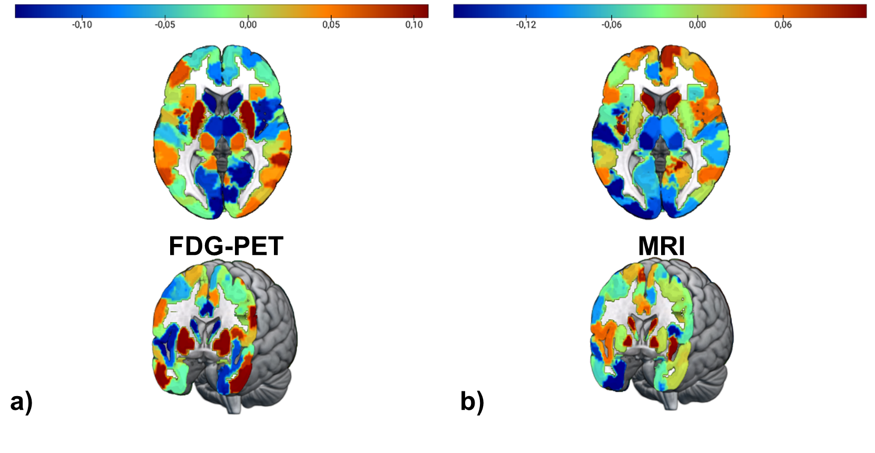

**Fig 3** **Feature importance for brain age prediction.** a) Average weights of support vector regression across three linear SVR for brain age prediction using FDG-PET. Weights were highly correlated across models (r > 0.8). b) Average weights of support vector regression across five linear SVR for brain age prediction using MRI. Weights were highly correlated across models (r > 0.8).

**3.3 BAG and Cognitive Performance**

Partial spearman correlations between BAG and composite scores for memory (ADNI-MEM) and executive function scores (ADNI-EF) were calculated to evaluate whether BAG is associated with cognitive performance in the two modalities with age and sex as covariates. To adjust for multiple comparisons, threshold levels of significance were adjusted by Bonferroni correction (p = .025). In CN (n = 345), there was no significant partial correlation between BAG and ADNI-MEM in either modality when controlling for age and sex. A weak, negative, partial correlation was detected between MRI-BAG and ADNI-EF (*ρ*(341)=-.150, *p* = .005).

In MCI (n = 511), significant, negative partial correlations between BAG and ADNI-MEM, as well as between BAG and ADNI-EF existed with BAG derived from either modality and from each of the five models (Table 3). Across models, median correlation coefficients were significantly stronger between MRI-BAG and ADNI-MEM compared to FDG-BAG (*z* = 3.56, *p* < .001).

**3.4 BAG and AD Neuropathology**

Partial spearman correlations were calculated between cross-sectional BAG and PET amyloid status (global AV45), CSF β-amyloid1–42 (CSF Aβ1-42), CSF total-tau (CSF Tau) and CSF phospho-tau181 (CSF pTau181) to evaluate whether BAG is associated with AD neuropathology in the two modalities. Age and sex were used as covariates. To adjust for multiple comparisons, threshold levels of significance were adjusted by Bonferroni correction (p = .0125). In CN (n = 266), a weak, negative, partial correlations existed between FDG-BAG and CSF Aβ1-42 (*ρ*(262)= -.160, *p* = .009). MRI-BAG was also partially correlated with CSF Aβ1-42 (*ρ(262)* = -.126, *p* = .040), however this correlation did not withstand Bonferroni correction. Other neuropathological measures were not associated with BAG in CN.

In MCI (n = 392 for CSF; n = 345 for AV45), partial correlations between BAG and AD neuropathology revealed that FDG-BAG was only marginally correlated with CSF Aβ42 across models, not always passing correction for multiple comparisons (CSF Aβ1-42: p < .05). MRI-BAG was significantly correlated with measures of amyloid load? across models. Moreover, partial correlations were observed between MRI-BAG and (p-)tau, which, however, did not withstand multiple comparison adjustment in the predictions of two (CSF total tau) and one (CSF pTau181) model(s) (CSF Tau: *p* = .006 - .046; pTau: *p* = .004 – .025).

|  |  |  |  |  |
| --- | --- | --- | --- | --- |
| Table 3. Correlation strength between BAG and neuropathology/cognitive function in MCI patients across five different models. | | | | |
|  | FDG-PET BAG | | MRI BAG | |
|  | Zero-order | Partial | Zero-order | Partial |
| CSF Aβ42 | -.184  [-.215, -.150] | -.174  [-.216, -.120] | -.290  [-.294, -.283] | -.262  [-.264, -.258] |
| Global AV45 | ns | ns | .204  [.189, .225] | .196  [.183, .205] |
| CSF Tau | ns | ns | ns | ns |
| CSF pTau | ns | ns | ns | ns |
| ADNI-MEM | -.236 [-.243; -.207] | -.208  [-.224; -.196] | -.437  [-.442; -.422] | -.409  [-.419; -.392] |
| ADNI-EF | -.237 [-.272; -.231] | -.224  [-.246; -.203] | -.300  [-.339; -.307] | -.290  [-.301; -.286] |
| *Notes.* Median [range] of Spearman correlation coefficients are displayed when significant correlation existed in brain-predicted age according to all five models (p < 0.0125 for neuropathology, p < 0.025 for cognitive performance). ns = not significant in all five models. | | | | |

**3.5 BAG and Cognitive Decline**

To assess the potential of BAG from the two modalities to serve as an indicator of cognitive decline, and to calculate thresholds for elevated risk of cognitive decline in CN and MCI, individuals’ diagnosis at year two was predicted from FDG-PET-BAG, MRI-BAG, APOE-e4 carriership, amyloid status and years of education.

99 CN participants received a clinical diagnosis of cognitive impairment six months to two years after baseline and thus constituted the decliner group. Two independent, equally-sized subsamples were automatically selected through matching for age and sex from the larger pool of individuals (n = 269) who maintained CN until year two (“stable group”). Individuals in both stable and the decliner groups, were on average 77 years old (not significantly different between each stable-decliner pair with α = 0.05), and 41-48% were female (not significantly different between each stable-decliner pair with α = 0.05), respectively. FDG-PET- and MRI-BAG were not significantly correlated in the two samples. In sample 1, FDG-PET-BAG significantly predicted CD with an odds ratio (OR) of 1.404 (95% CI [1.113, 1.847], for logistic regression estimates, see Table 4). In sample 2, FDG-PET-BAG (OR = 1.298, 95% CI [1.013, 1.734]) and amyloid status (OR = 5.011, 95% CI [1.197, 25.363]) marginally to significantly predicted CD. To derive an FDG-PET-BAG threshold for elevated risk of cognitive decline, we subsequently extracted FDG-PET-BAG and probability of cognitive decline as estimated by the logistic regression models, and extracted the participant with an estimated probability closest to 50%. -0.75, and 0.01 years FDG-PET-BAG corresponded to 50.6 and 49.5% probability of cognitive decline in the two samples, respectively, and thus represented this threshold (**Fig. 4**).

In both samples, we then fitted a new logistic regression model using only (marginally) significant variables to determine a cut-off for BAG, that is, PET-BAG for sample 1 and amyloid status and PET-BAG for sample 2. These models had an AUC of 73% and 72%, respectively. 50% disease probability (our criterion for the cut-off) was reached at 0.3 and -0.1 years PET-BAG in samples 1 and 2, respectively (), indicating that any positive deviation of BPA from CA yields an elevated risk for CD. To test whether the risk for CD according to FDG-PET-BAG could be considered as a function of amyloid status, we additionally observed thresholds of 50% disease probability within categories of amyloid status. However, as can be seen in **Fig. 4**, the logistic regression classifier strongly leaned its decision on amyloid status, thereby depriving the inferred thresholds of -2.7 and 2.3 years FDG-PET-BAG for amyloid positive and negative CN, respectively, of clinical utility. Nevertheless, the density plots show that even within categories of amyloid status, decliners show an advanced BAG compared to stables.

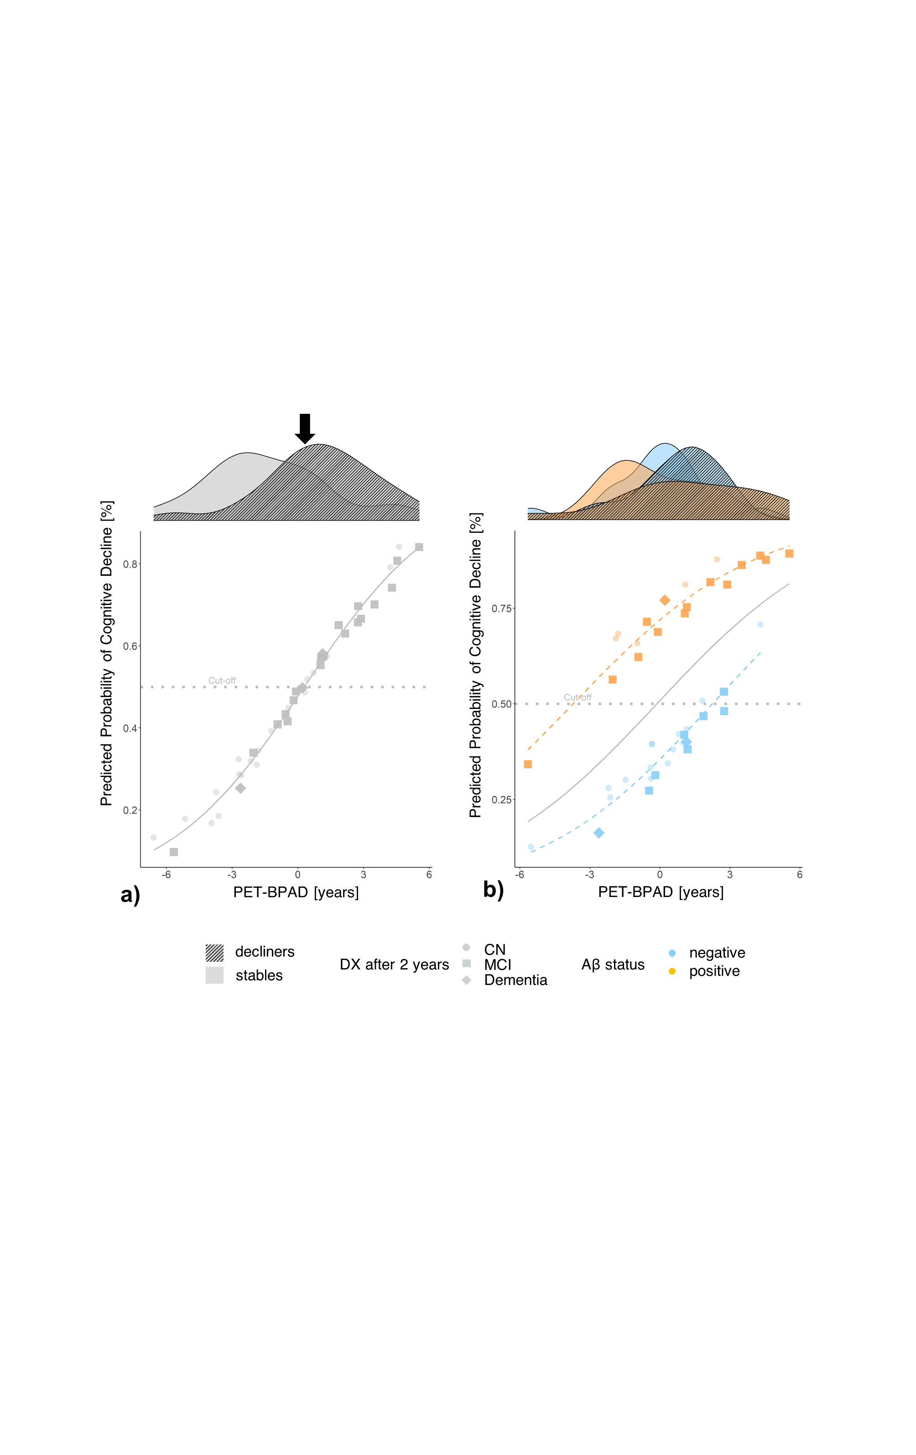

**Fig. 4** **Cross-validated probability of CD within two years after a baseline diagnosis of CN by PET-BAG.** The gray lines depict smoothed probability curves yielded from logistic regression predictions. Transparency of stable individuals is increased for for visibility. a) CD predicted from FDG-BAG only. Higher PET-BAG was the only significant predictor of CD in sample one. The PET-BAG-derived threshold for CD in sample 1 (50% probability of CD; dotted line) was .3 years (as indicated by dotted line and black arrow). The density plots show that most stables show a lower BAG, while most decliners have a higher BAG. b) CD predicted from FDG-BAG and amyloid status. Amyloid positivity and marginally FDG-PET predicted CD in sample two. The PET-BAG-derived decision boundary in sample 2 was .4 years. DX = diagnosis.

After removing those individuals who did not have information on amyloid status available, a complete sample of 23 decliners remained, thus constituting a sample size of 46. Results from the complete samples were largely consistent with results obtained from the whole samples and can be found in the Supplementary Materials, section “Prediction of Cognitive Decline”.

|  |  |  |  |  |
| --- | --- | --- | --- | --- |
| Table 4 Estimates (p-values) of logistic regression for prediction of cognitive decline. | | | | |
|  | CN | | MCI | |
|  | Sample  (n = 58) | Sample 2  (n = 58) | Sample 1  (n = 200) | Sample 2  (n = 200) |
| FDG-PET-BAG [Years] | .340 (<.01) | .261 (.05) | .131 (.17) | .114 (.20) |
| MRI-BAG [Years] | .037 (.78) | .032 (.77) | .420 (<.0001) | .373 (<.0001) |
| Aβ+ | .026 (.97) | 1.612 (.04) | 1.191 (<.05) | .803 (.15) |
| APOE-ε4+ | 1.464 (.10) | -.066 (.92) | 1.205 (<.01) | 1.45 (<.0001) |
| Education [Years] | -.136 (.22) | -.060 (.57) | -.064 (.38) | -.058 (.39) |

99 MCI patients received a clinical diagnosis of dementia six months to two years after baseline and thus constituted the decliner group. Seventy-nine decliners had a positive amyloid status at or before the time point of a dementia diagnosis, and could thus be considered Alzheimer’s disease patients, while one individual was amyloid negative, and 19 had no information on amyloid status. One MCI patient who was diagnosed with dementia in month six, but with MCI in a later assessment (month 12), was excluded from the current analyses. Two independent, equally-sized subsamples were automatically selected through matching for age and sex from the larger pool of individuals (n = 293) who maintained an MCI diagnosis until year two (“stable group”). Individuals in both stable and the decliner groups, were on average 75 years old (not significantly different between each stable-decliner pair with α = 0.05), and 38 – 52% were female (not significantly different between each stable-decliner pair with α = 0.05), respectively. Across the two matched sub-samples, FDG-PET- and MRI-BAG were correlated (r­sample1 = .501; psample1 < .0001; rsample2 = .410; psample2 < .0001). In both samples, higher MRI-BAG very significantly predicted CD (sample 1: OR = 1.522, 95% CI [1.292, 1.829]; sample 2: OR = 1.453, 95% CI [1.244, 1.724]) together with APOE-ε4 carriership. Notably, MRI-BAG showed higher significance compared to most other risk factors (see Table 3). A complete overview of odds ratios is available in Supplementary Fig. S1. To derive an MRI-BAG threshold for elevated risk of cognitive decline, we subsequently extracted MRI-BAG and probability of cognitive decline as estimated by the logistic regression model, and extracted the participant with an estimated probability closest to 50%. 1.75, and 2.11 years MRI-BAG corresponded to 49.6 and 50.7% probability of cognitive decline in the two samples, respectively, and thus represented this threshold. We further observed how MRI-BAG predicted cognitive decline as a function of APOE-ε4 carriership, which was identified as an additional predictor of cognitive decline. In APOE-ε4 non-carriers, the threshold for cognitive decline was considerably higher across samples (3.50 and 4.26 years MRI-BAG corresponded to 49.4 and 50.5% probability of cognitive decline in samples 1 and 2, respectively), compared to APOE-ε4 carriers (0.22 and 0.13 years MRI-BAG corresponded to 50.8 and 49.6% probability of cognitive decline in samples 1 and 2, respectively, see **Fig. 5**). Thus, APOE-ε4 carriers present with an enhanced probability of cognitive decline even in the relative absence of advanced brain aging, as apparent from MRI.

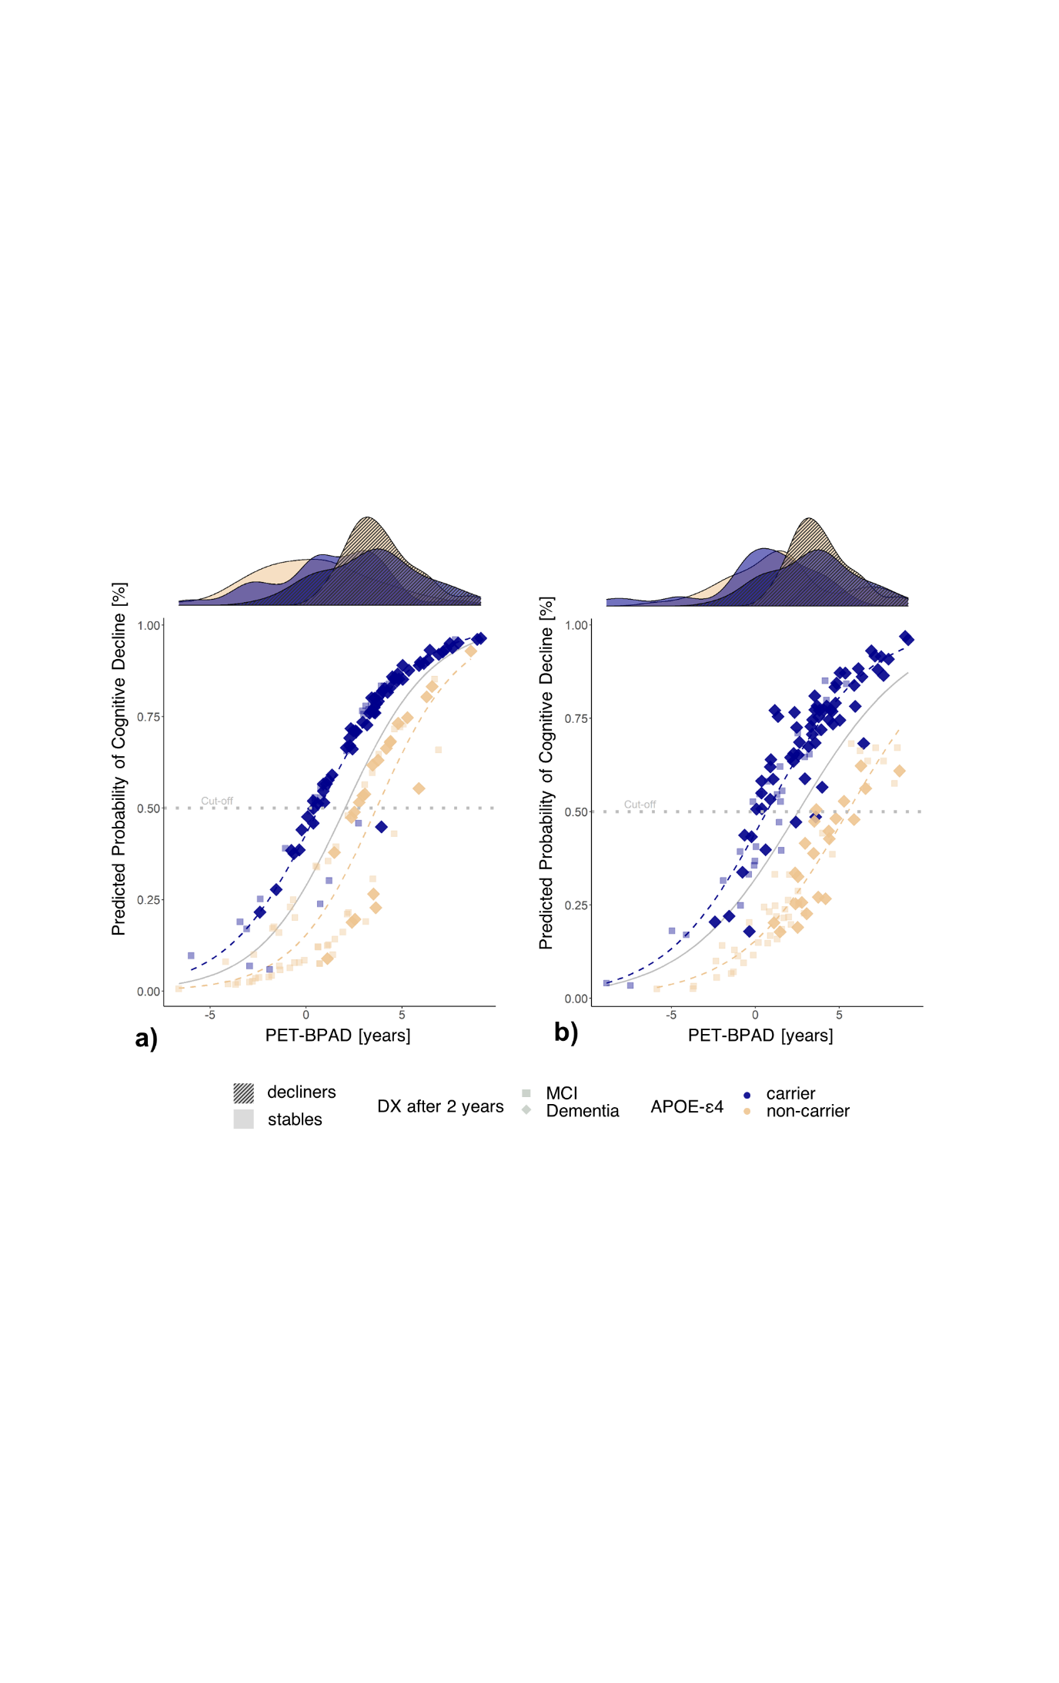

We repeated our analyses with a subset of 85 decliners and matched stables, who offered full information on all considered variables. Results from these complete samples were largely consistent with results obtained from the whole samples and can be found in the Supplementary Materials, section “Prediction of Cognitive Decline”. Finally, due to the correlation observed between PET- and MRI-BAG in the MCI sample, we additionally assessed logistic regression models with unimodal BAG10. Considered in separate models, both MRI- and PET-BAG very significantly predicted CD (see Supplementary Tables S2 and S3 for estimates of logistic regression in whole samples) together with APOE-e4 carriership (and amyloid status).

**Fig. 5 Cross-validated probability of cognitive decline within two years after a baseline diagnosis of MCI by MRI-BAG.** The gray lines depict smoothed probability curves yielded from logistic regression predictions. Transparency of stable individuals is increased for for visibility. a) The MRI-BAG-derived cut-offs for CD in sample 1 (dotted line) was 2.3 years. This cut-off differed as a function of APOE-ε4 carriership, where APOE-ε4 carriers showed a considerably lower cut-off. b) The MRI-BAG-derived decision boundary in sample 2 was 2.5 years. Again, APOE-ε4 carriers displayed a lower cut-off of MRI-BAG for CD. Density plots show that CD is well predictable from MRI-BAG among APOE-ε4 (non-)carriers. DX = diagnosis.

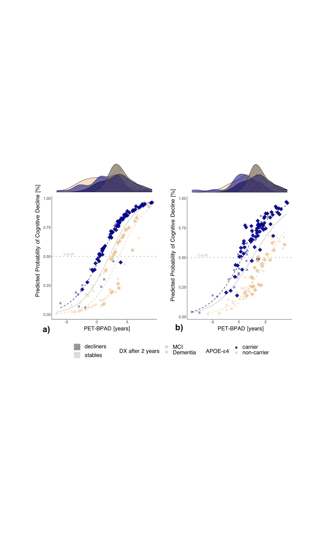

**4 Discussion**

While numerous works exist on the relationship between brain age and neurodegenerative diseases, recommendations for BAG as an individual-level biomarker of AD, required to integrate it into clinical practice, are rare. Here, we have shown that FDG-PET predicts brain age equally well? as MRI, and FDG-BAG can serve as a marker of cognitive decline providing information complementary to MRI-BAG. We demonstrated that FDG-BAG is superior in representing AD neuropathology and risk of cognitive decline in CN. MRI-BAG, on the other hand, was more closely associated with a decline of executive function within the range of a CN diagnosis, as well as memory function, AD neuropathology and cognitive decline in MCI. Importantly, we identified that CN with an FDG-BAG > 0 are at elevated risk for cognitive decline, while the cut-off for MCI lies around an MRI-BAG of 2.4 years.

Congruent with previous work, our findings underline that FDG-PET shows greater and more consistent changes early in the AD continuum (e.g. a decrease of Aβ1-42 in CSF), whereas MRI is superior in delineating AD-related changes with an AD diagnosis (e.g. onset of tau-related neurodegeneration)8. Among the CN population, our results may be most relevant to individuals experiencing subjective cognitive impairment (SCI). Persons with SCI recognize cognitive deficits before they become objectively measurable. These individuals were shown to be more likely to develop MCI or AD compared to CN without SCI11. Differences on MRI brain age between CN and SCI have previously been shown, as SCI demonstrated a BAG advanced by 1.1 years3. However, as we have shown here, for individuals without objective cognitive impairment, FDG-BAG serves as a better biomarker to measure neuropathological variability and risk of CD. Individuals presenting to a memory clinic with SCI could in the future be recommended an FDG-PET. Should their brain age exceed their chronological age, our current results yield a justification for a need of close monitoring of symptoms and potential therapeutic interventions.

Early detection of pathological abnormality is among the most crucial concepts in preventing AD. According to the *amyloid cascade hypothesis*, amyloid deposition is the causative agent of AD, causing a downstream effect of tau deposition, neurodegeneration and dementia12. Several promising anti-amyloid therapies are currently under assessment or have recently been approved for the treatment of MCI and early AD. The inclusion of BAG into clinical trials of AD could have several advantages. First, we have shown that BAG serves as a biomarker of cognitive decline in both, CN and MCI. Since cognitive decline is often an outcome factor of these trials, the notion of BAG could help to identify those individuals who are most at risk of cognitive decline, thereby strongly reducing the number of participants and thus cost of treatment trials. Secondly, BAG is an established summary marker of brain health13. Brain age prediction algorithms are trained on a cognitively normal cohort and we have shown that BAG reliably detects current and pending deviations from normal cognitive performance. Thus, it also appears possible to consider BAG itself as an outcome variable of neuroscientific clinical trials, potentially reflecting drug action on the whole brain above and beyond variables of interest. Importantly, given that it is hardly possible to restore brain structures lost to neurodegeneration, MRI brain age is unlikely to decrease, but only to decelerate. On the other hand, it appears possible that a decreased metabolism can be strengthened and increased again by certain interventions, thus underlining the here postulated importance of choice of modality for brain age prediction.

Lee: FDG-PET scans were pre-processed using partial volume correction and are thus influenced by MRI information 🡪 fallacy as not really a comparison. Our study confirms findings except find stronger difference in associations between AD biomarkers, cognitive decline, … BPA not correlated in CN

In the MCI population, differential cut-offs were identified for APOE-ε4 carriers and non-carriers, with cut-offs for APOE-ε4 carriers being as low as 0.7 years on MRI, which is well below the average BAG of this group identified here (1.57 years on MRI). Post-hoc analyses confirmed that APOE-ε4 carriers also showed a higher MRI-BAG (2.11 years) compared to APOE-ε4 non-carriers. These findings support the notion that BAG increases more strongly in APOE-ε4 carriers5. The APOE lipoprotein is involved in lipid transport, metabolism, inflammatory response signaling and pathology clearance mechanisms, for example of cerebral amyloid14. In our analyses, APOE-ε4 carriership was a significant predictor of CD in both MCI samples, while amyloid status only predicted cognitive decline in one sample. This was likely attributable to the fact that we investigated decline from MCI to dementia, rather than AD, in order to retain a considerable sample size of decliners. While APOE is associated with a variety of neurological conditions, amyloid is rather AD-specific. Together, these findings underline the pivotal role of genetic predisposition for several dementias and other neurological conditions in individuals carrying at least one ε4 allele14–18, and are in favor of the combined observation of genetic and neurodegenerative patterns for disease risk assessment19.

Some limitations should be acknowledged. Only one of two samples evidenced usability of BAG for prediction of CD in CN. The purpose of using two different matched samples was to obtain an indicator of reliability of the obtained results. The different results on the two samples could be due to the small sample size of decliners. Therefore, the implementation of FDG-BAG as a biomarker in CN requires confirmation by future studies including a larger sample of decliners. Moreover, it is not a straightforward to acquire FDG-PET scans from a CN population, as PET scans require logistic availability, comparably high cost, and the injection of a radioactive tracer. However, whether the multi-dimensional feature space of FDG-PET can be replaced by easier accessible fluid biomarkers of neurodegeneration, and whether they would reflect brain aging, is questionable. Finally, our definition of CN only required for the absence of objective cognitive impairment, but not normality according to specific biomarkers, thus some participants with underlying amyloid pathology were included into our training sample. However, here the choice was to train our models to capture potential pathological heterogeneity of cognitively normal individuals to obtain a realistic estimate of brain aging.

In conclusion, we have shown that FDG-PET and MRI can and must both be used for brain age prediction: While FDG-PET better captures deviations from normal aging in CN, MRI is the superior modality in individuals with MCI. We have developed BAG cut-offs for estimation of risk in CN and MCI, which could support the identification of patients in need of frequent monitoring at an early time point, as well as support clinical trials, both methodologically, and financially.

**References**

1. Nie, C. *et al.* Distinct biological ages of organs and systems identified from a multi-omics study. *Cell Rep.* **38**, (2022).

2. Beheshti, I., Mishra, S., Sone, D., Khanna, P. & Matsuda, H. T1-weighted MRI-driven brain age estimation in Alzheimer’s disease and Parkinson’s disease. *Aging Dis.* **11**, (2020).

3. Rokicki, J. *et al.* Multimodal imaging improves brain age prediction and reveals distinct abnormalities in patients with psychiatric and neurological disorders. *Hum. Brain Mapp.* **42**, (2021).

4. Lee, J. *et al.* Deep learning-based brain age prediction in normal aging and dementia. *Nat. Aging* (2022) doi:10.1038/s43587-022-00219-7.

5. Löwe, L. C., Gaser, C. & Franke, K. The effect of the APOE genotype on individual BrainAGE in normal aging, Mild cognitive impairment, and Alzheimer’s Disease. *PLoS One* **11**, (2016).

6. Gaser, C., Franke, K., Klöppel, S., Koutsouleris, N. & Sauer, H. BrainAGE in Mild Cognitive Impaired Patients: Predicting the Conversion to Alzheimer’s Disease. *PLoS One* **8**, (2013).

7. Jack, C. R. *et al.* Hypothetical model of dynamic biomarkers of the Alzheimer’s pathological cascade. *The Lancet Neurology* vol. 9 119–128 (2010).

8. Dukart, J. *et al.* Generative FDG-PET and MRI Model of Aging and Disease Progression in Alzheimer’s Disease. *PLoS Comput. Biol.* **9**, e1002987 (2013).

9. Beheshti, I. *et al.* Predicting brain age using machine learning algorithms: A comprehensive evaluation. *IEEE J. Biomed. Heal. Informatics* (2021) doi:10.1109/JBHI.2021.3083187.

10. Ranganathan, P., Pramesh, C. & Aggarwal, R. Common pitfalls in statistical analysis: Logistic regression. *Perspect. Clin. Res.* **8**, (2017).

11. Parfenov, V. A., Zakharov, V. V., Kabaeva, A. R. & Vakhnina, N. V. Subjective cognitive decline as a predictor of future cognitive decline a systematic review. *Dement. e Neuropsychol.* **14**, (2020).

12. Hardy, J. A. & Higgins, G. A. Alzheimer’s disease: The amyloid cascade hypothesis. *Science* (1992) doi:10.1126/science.1566067.

13. Cole, J. H., Marioni, R. E., Harris, S. E. & Deary, I. J. Brain age and other bodily ‘ages’: implications for neuropsychiatry. *Molecular Psychiatry* vol. 24 (2019).

14. Troutwine, B. R., Hamid, L., Lysaker, C. R., Strope, T. A. & Wilkins, H. M. Apolipoprotein E and Alzheimer’s disease. *Acta Pharmaceutica Sinica B* vol. 12 496–510 (2022).

15. Roses, A. D. & Saunders, A. M. APOE is a major susceptibility gene for Alzheimer’s disease. *Curr. Opin. Biotechnol.* **5**, (1994).

16. Li, Y. J. *et al.* Apolipoprotein E controls the risk and age at onset of Parkinson disease. *Neurology* **62**, (2004).

17. Crawford, F. C. *et al.* APOE genotype influences acquisition and recall following traumatic brain injury. *Neurology* **58**, (2002).

18. Fazekas, F. *et al.* Apolipoprotein E ε4 is associated with rapid progression of multiple sclerosis. *Neurology* **57**, (2001).

19. Doering, E. *et al.* Introducing a Gatekeeping Methodology for Amyloid Status Assessment in Mild Cognitive Impairmenttle. *Eur. J. Nucl. Med. Mol. Imaging*.

20. LaMontagne, P. J. *et al.* OASIS-3: Longitudinal neuroimaging, clinical, and cognitive dataset for normal aging and Alzheimer disease. *medRxiv* (2019) doi:10.1101/2019.12.13.19014902.

21. Verger, A., Doyen, M., Campion, J. Y. & Guedj, E. The pons as reference region for intensity normalization in semi-quantitative analysis of brain 18FDG PET: application to metabolic changes related to ageing in conventional and digital control databases. *EJNMMI Res.* **11**, 1–7 (2021).

22. Jack, C. R. *et al.* The Alzheimer’s Disease Neuroimaging Initiative (ADNI): MRI methods. *Journal of Magnetic Resonance Imaging* vol. 27 (2008).

23. Schaefer, A. *et al.* Local-Global Parcellation of the Human Cerebral Cortex from Intrinsic Functional Connectivity MRI. *Cereb. Cortex* **28**, (2018).

24. Tian, Y., Margulies, D. S., Breakspear, M. & Zalesky, A. Hierarchical organization of the human subcortex unveiled with functional connectivity gradients. *bioRxiv* (2020) doi:10.1101/2020.01.13.903542.

25. Pedregosa, F. *et al.* *Scikit-learn: Machine Learning in Python Gaël Varoquaux Bertrand Thirion Vincent Dubourg Alexandre Passos PEDREGOSA, VAROQUAUX, GRAMFORT ET AL. Matthieu Perrot*. *Journal of Machine Learning Research* vol. 12 http://scikit-learn.sourceforge.net. (2011).

26. Suzman, R. & Riley, M. W. Introducing the ‘oldest old’. *Milbank Mem. Fund Q. Health Soc.* **63**, (1985).

27. Baecker, L. *et al.* Brain age prediction: A comparison between machine learning models using region- and voxel-based morphometric data. *Hum. Brain Mapp.* **42**, (2021).

28. Beheshti, I., Nugent, S., Potvin, O. & Duchesne, S. Bias-adjustment in neuroimaging-based brain age frameworks: A robust scheme. *NeuroImage Clin.* **24**, (2019).

29. Liang, H., Zhang, F. & Niu, X. Investigating systematic bias in brain age estimation with application to post-traumatic stress disorders. *Hum. Brain Mapp.* **40**, (2019).

30. de Lange, A. M. G. & Cole, J. H. Commentary: Correction procedures in brain-age prediction. *NeuroImage: Clinical* vol. 26 (2020).

31. Cole, J. H. *et al.* Brain age predicts mortality. *Mol. Psychiatry* **23**, (2018).

32. Crane, P. K. *et al.* Development and assessment of a composite score for memory in the Alzheimer’s Disease Neuroimaging Initiative (ADNI). *Brain Imaging Behav.* **6**, (2012).

33. Gibbons, L. E. *et al.* A composite score for executive functioning, validated in Alzheimer’s Disease Neuroimaging Initiative (ADNI) participants with baseline mild cognitive impairment. *Brain Imaging Behav.* **6**, (2012).

34. Landau, S., Koeppe, R. & Jagust, W. *Florbetaben processing and positivity threshold derivation Motivation for changing the threshold*. (2011).

35. Landau, S. & Jagust, W. *Florbetapir processing methods*. (2011).

36. Jagust, W. J. *et al.* Relationships between biomarkers in aging and dementia. *Neurology* **73**, 1193–1199 (2009).

37. Jagust, W. J. *et al.* The Alzheimer’s Disease Neuroimaging Initiative positron emission tomography core. *Alzheimer’s Dement.* **6**, (2010).

38. Blennow, K. *et al.* Predicting clinical decline and conversion to Alzheimer’s disease or dementia using novel Elecsys Aβ(1–42), pTau and tTau CSF immunoassays. *Sci. Rep.* **9**, (2019).

39. Hansson, O. *et al.* CSF biomarkers of Alzheimer’s disease concord with amyloid-β PET and predict clinical progression: A study of fully automated immunoassays in BioFINDER and ADNI cohorts. *Alzheimer’s Dement.* **14**, (2018).

**Statements & Declarations**

**Author Contributions**

All authors contributed to the study conception and design. Material preparation, data collection and analysis were performed by ED and GA, in support of KP and MH. KP, TvE, SE and AD jointly supervised this work. The first draft of the manuscript was written by ED and all authors commented on previous versions of the manuscript. All authors read and approved the final manuscript.

**COMPETING INTERESTS**

MH reports no conflict of interest.

**Funding**

Maybe mention SFB?

Data collection and sharing for this project was funded by the Alzheimer's Disease Neuroimaging Initiative (ADNI) (National Institutes of Health Grant U01 AG024904) and DOD ADNI (Department of Defense award number W81XWH-12-2-0012). ADNI is funded by the National Institute on Aging, the National Institute of Biomedical Imaging and Bioengineering, and through generous contributions from the following: AbbVie, Alzheimer's Association; Alzheimer's Drug Discovery Foundation; Araclon Biotech; BioClinica, Inc.; Biogen; Bristol-Myers Squibb Company; CereSpir, Inc.; Cogstate; Eisai Inc.; Elan Pharmaceuticals, Inc.; Eli Lilly and Company; EuroImmun; F. Hoffmann-La Roche Ltd and its affiliated company Genentech, Inc.; Fujirebio; GE Healthcare; IXICO Ltd.;Janssen Alzheimer Immunotherapy Research & Development, LLC.; Johnson & Johnson Pharmaceutical Research & Development LLC.; Lumosity; Lundbeck; Merck & Co., Inc.;Meso Scale Diagnostics, LLC.; NeuroRx Research; Neurotrack Technologies; Novartis Pharmaceuticals Corporation; Pfizer Inc.; Piramal Imaging; Servier; Takeda Pharmaceutical Company; and Transition Therapeutics. The Canadian Institutes of Health Research is providing funds to support ADNI clinical sites in Canada. Private sector contributions are facilitated by the Foundation for the National Institutes of Health ([www.fnih.org](https://ida.loni.usc.edu/collaboration/access/www.fnih.org)). The grantee organization is the Northern California Institute for Research and Education, and the study is coordinated by the Alzheimer's Therapeutic Research Institute at the University of Southern California. ADNI data are disseminated by the Laboratory for Neuro Imaging at the University of Southern California.

1. Data used in preparation of this article were obtained from the Alzheimer's Disease Neuroimaging Initiative (ADNI) database (adni.loni.usc.edu). As such, the investigators within the ADNI contributed to the design and implementation of ADNI and/or provided data but did not participate in analysis or writing of this report. A complete listing of ADNI investigators can be found at: <http://adni.loni.usc.edu/wp-content/uploads/how_to_apply/ADNI_Acknowledgement_List.pdf>
2. Mean and standard deviation indicated from absolute difference in days
3. An outlier exclusion procedure was included in our cross-validation approach. Outlier ranges were estimated based on the training set and test subjects falling in these ranges were subsequently excluded from brain age prediction.